**Team Description Paper**

**(Cover Page)**

|  |  |
| --- | --- |
| League Name: | RoboCup junior rescue maze |
| Age Group: | Junior |
| Team Name: | BAUM-TECH |
| Team Website: | ----- |
| Participants Name: | Konstantin Konnov  Artem Peshnin  Pavlov Dmitriy |
| Mentor Name: | Madin Shereushev |
| Institution: | BMSTU |
| Country: | Russia |
| Contact Person: | Konnov Konstantin, Kovalenko Larisa |
| Contact Email: | [Kostyan40k@mail.ru](mailto:Kostyan40k@mail.ru), pptopol@yandex.ru |
| Date: | 29.03.2020 |

**Team Description Paper**

RoboCup junior rescue maze

Konstantin Konnov, Artem Peshnin, Pavlov Dmitriy

BAUM-TECH, BMSTU, Russia,

Introduction

* 1. Team Background
  2. Team website (if you have one)
  3. Team photo (optional)
  4. Provide any video link (URL) related to your team and challenge if any (optional)
  5. Previous RoboCup or other robotics experience

1. Strategy
   1. Robot Design and structure (except all CoSpace Challenges)
   2. Description of your AI strategy.
   3. Include flowcharts or pseudo code if appropriate
   4. Describe and highlight innovative algorithms in any
2. Track Record
   1. RoboCup Achievement
   2. Other robotics competition achevement
3. Discussion and Conclusion
   1. Share your team’s learning experience
   2. Highlight collaboration with other teams if any
   3. Description of future work
4. Acknowledgements
5. References

Introduction

Team background

We are the robotics team from Moscow. We started 1 year ago and begin to participate in RoboCup junior rescue Maze held in Moscow. After qualifier, we participated in Robocup Russia opens 2019, and won award: “Best technical solution”, then we were in Germany at Robocup Euro 2019. We ended 2019 to participate in Moscow at RoboCup Asia-pacific and won here “Best technical solution”.

Team photo

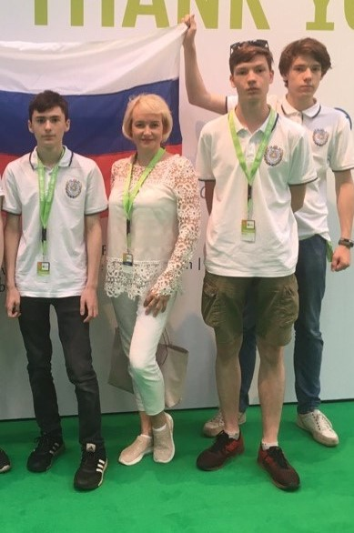

Video

In case of quarantine we had no opportunity to record this video in our training field, so we made it at home

Victim detection: <https://youtu.be/MaxKoMhLJ98>

Solving the maze: <https://www.youtube.com/watch?v=48IiebxwUEE>

Previous experience

1-st place at Moscow qualification RoboCup junior rescue maze (2019)

Best technical solution award at RoboCup Russia Open Tomsk 2019

Participation at Robocup Euro 2019

Best technical solution award at RoboCup Asia-pacific 2019

Strategy

1. Our robot has a closed case, it protects its electronics from the external environment and prevents damage from foreign objects. It has tank tracks to improve cross-country performance. On the back, there is a fan, which protects electronics from overheating. Its case is designed by our team and 3d-printed. Inside the robot there are 2 boards: Odroid c2 and OpenCR. OpenCR controls 2 dynamixels mx 64 (servos, which move our robot), calculates odometry and processes data from temperature and line sensor. Odroid is used for mapping, movement planning, and processing images from 2 web cameras. Obstacle detection is implemented with the help of lidar, which mounted on the top of our robot.

1. The robot moves forward until dead end, marks all the visited forks on its map, then returns to the last unmarked fork and rotates right or left to explore a new path. When all the forks are marked as visited, it moves to the start point.

Computer vision scheme

1. 

Track Record

We participate only in RoboCup

Achievements:

* 1-st place at Moscow qualification RoboCup junior rescue maze (2019)
* Best technical solution award at RoboCup Russia Open Tomsk 2019
* Participation at Robocup Euro 2019
* Best technical solution award at RoboCup Asia-pacific 2019

Discussion and conclusion

We learned a lot during preparation for RoboCup. We increased our programming, 3-D modelling, soldering, and engineering skills.

After junior leagues, we plan to participate in RoboCup major leagues